**Ui Path RPA Architeture**

**Ui path platform components**

Ui path components mainly classified into 3

* **Ui Path studio**
* **Ui Path robot**
* **Ui Path orchestrator**

**Ui Path studio :** A visual designer which lets you build automation workflow with pre-building activity. They includes

* GUI dash board
* Complexity level
* Types of recorders
* Logging & exception handling
* Integrate with OCR technology
* Reusable components

**Ui Path robot :** It is the basic component which executed the created automation work flow uipath studio.

Automation work flow created in ui path studio.it executed by uipath robots.

**Ui Path orchestrator :** Ui path orchestrator to orchestrator the ui path robots in continuously executing repetitive process on various platforms.

**UI PATH ARCHITETURE**

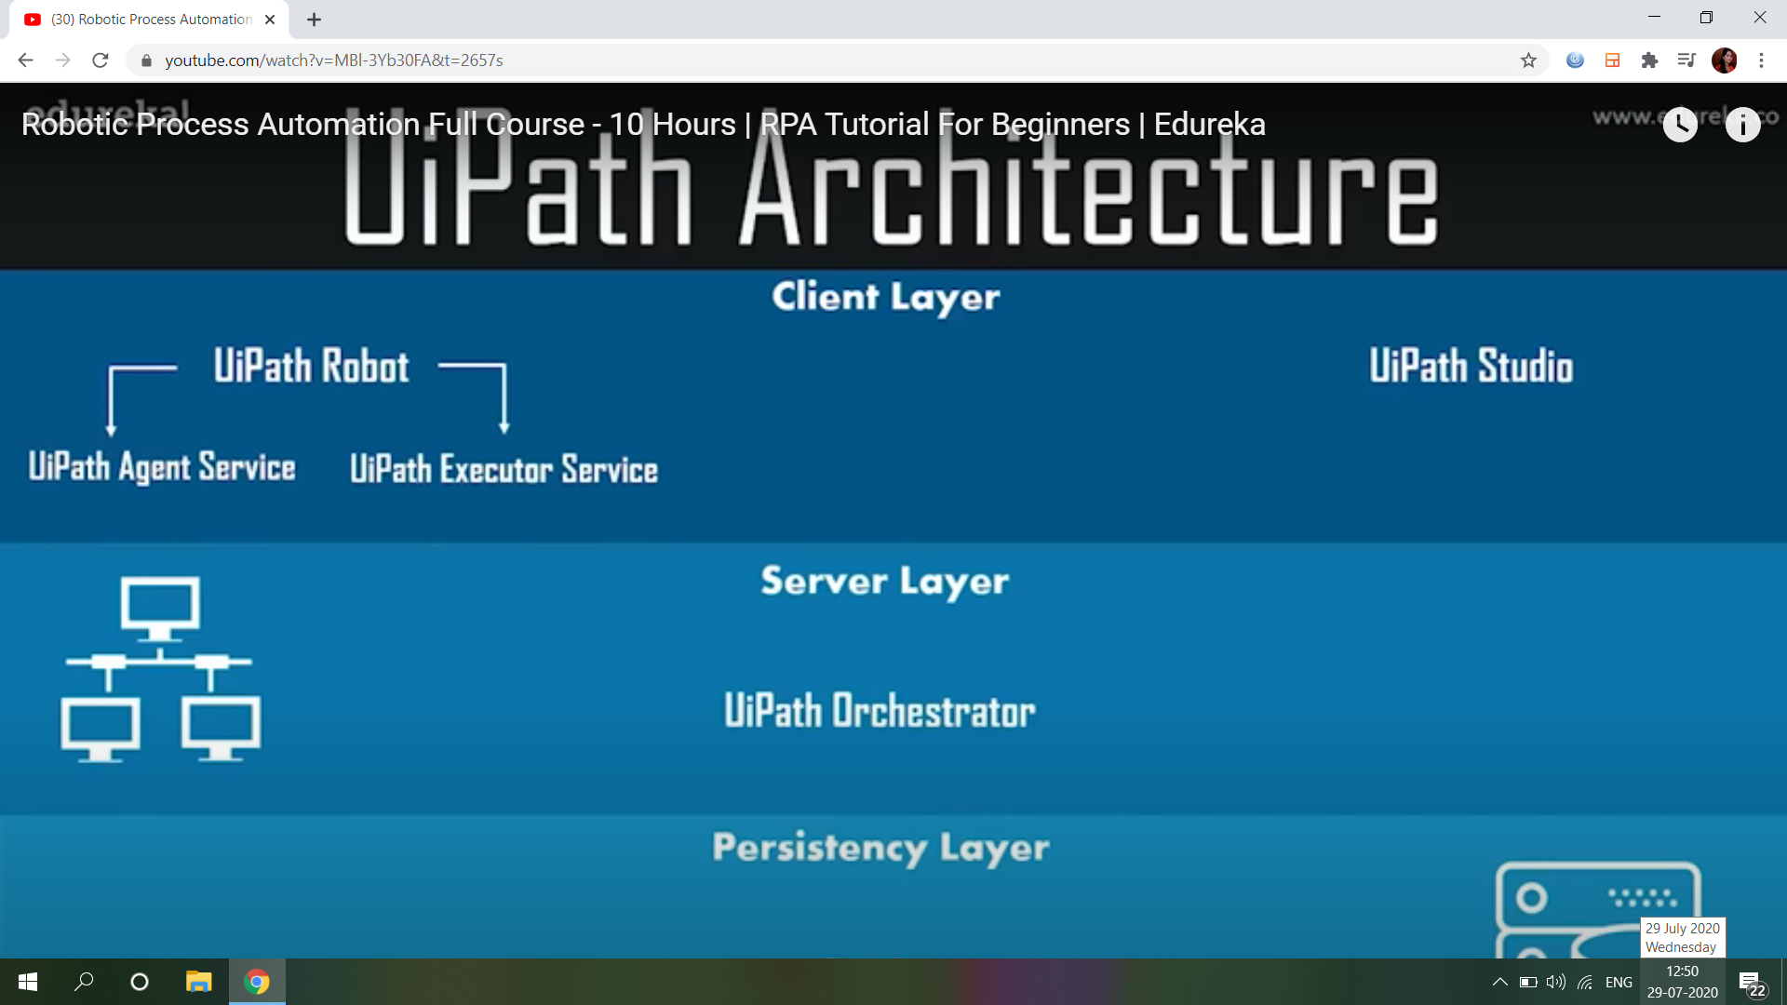

UIPATH architecture mainly classified into 3 layers

* **Client Layer** : It is the develop set layer.it is create new automation workflow. we have uipath studio and robot it is creates and execute layer.
* **Server Layer** : It basically has the uipath orchestrator, which takes the monitoring, deployment, configuration, queue management, login of the task, automation work flow.
* **Persistency Layer** : It layer basis on the database.

**VARIABLES, DATATYPES AND ACTIVITY IN UIPATH**

**VARIABLES**

Create remove manage

VariablesVariables variables

**Types of variables**

**Text variable:** It is used by text in the workflow.

**True/false variable**: it have two condition, true or false in the workflow.

**Number variables**: it is using the numerical values in the workflow.

**Date& time variables**

**Data table**

**Generic**

**DATA TYPES**

UiPath studio using different datatypes. they are

* **Integer :** it using the integer value in the workflow
* **String:** it using string values
* **Boolean:** in the Boolean variables are using two condition ie,0 and 1
* **Generic**
* **Array of**

**ACTIVITIES**

Activities in uipath provides various actions which you need to automate different applications.they are including,

* **Message box**
* **Assign**
* **For each**
* **Switch**
* **Write csv**
* **While**
* **Do while**

**Message box**

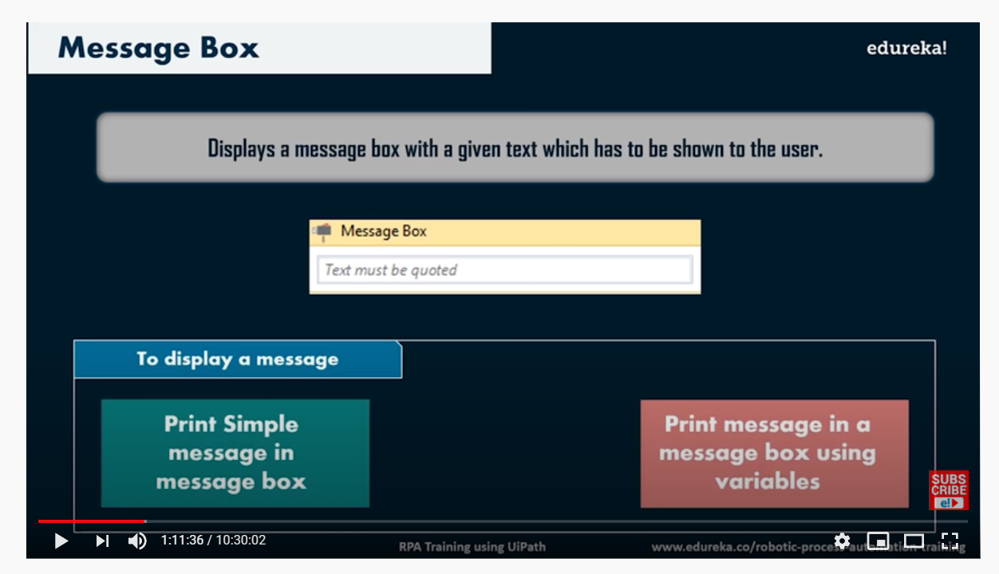

**Assign**

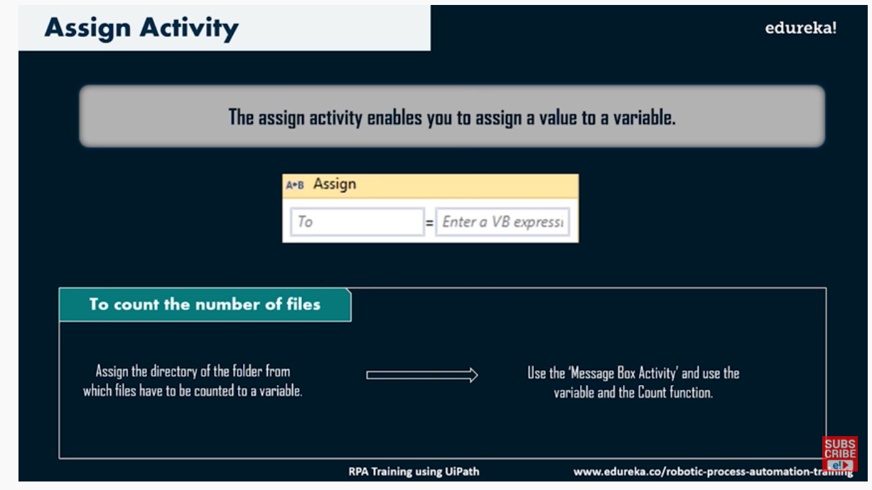

**For each**

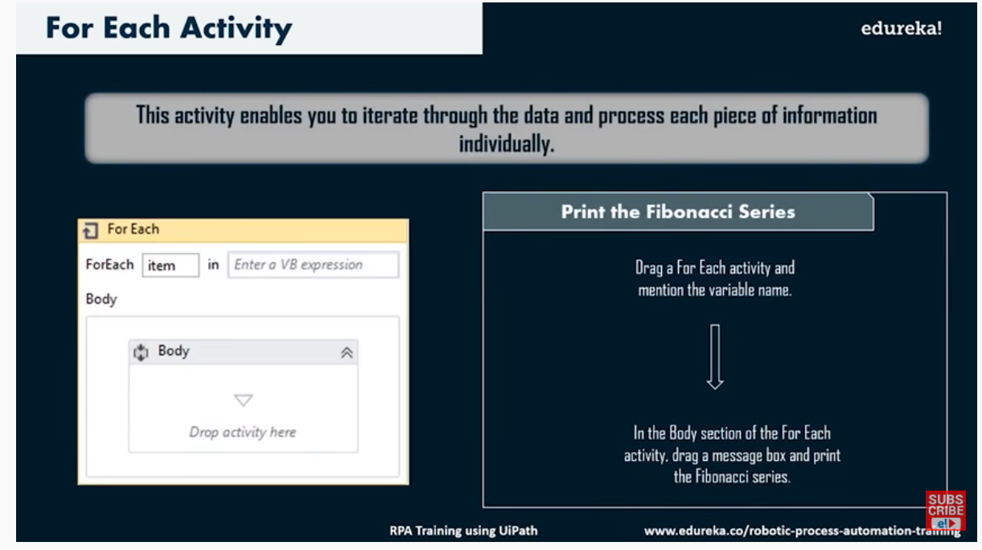

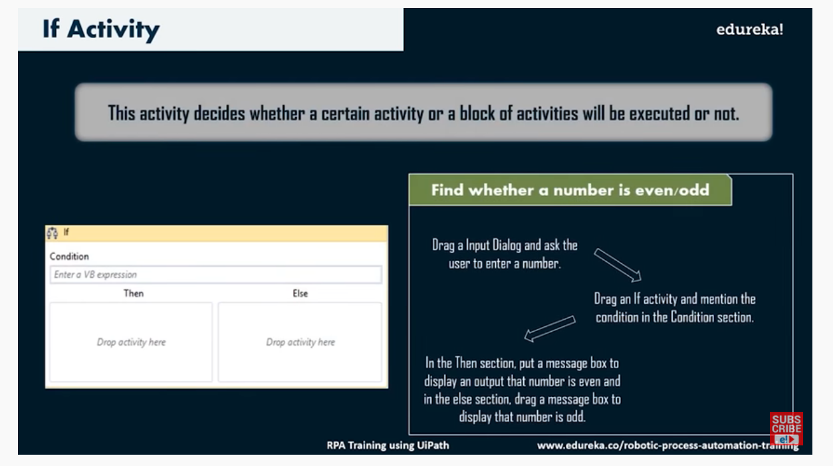

**Do While**

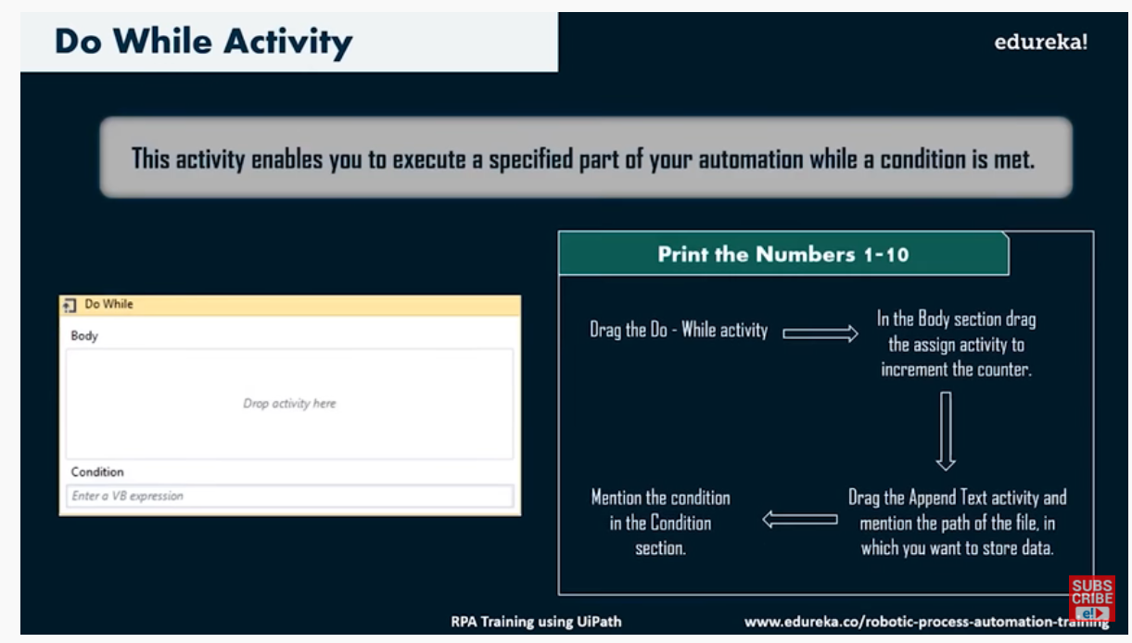

**Write CSV**

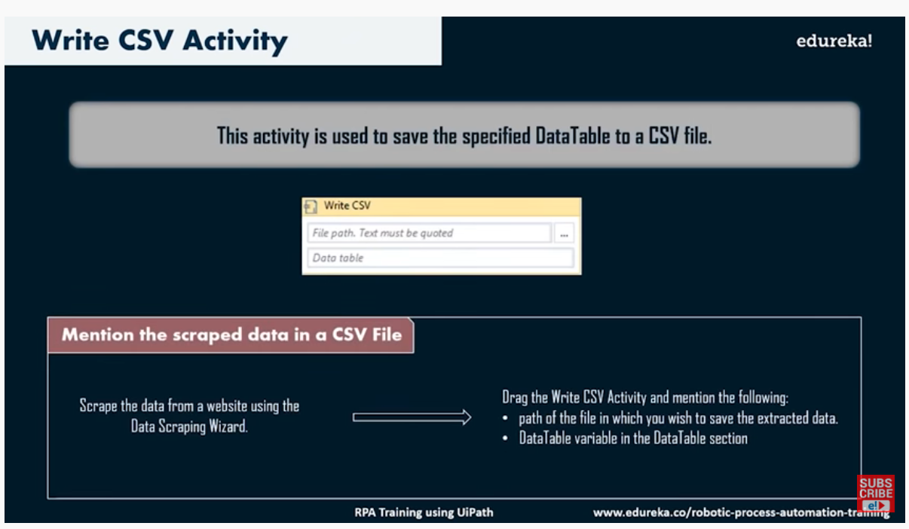

**While CSV**

